**Front office process**

Mobile Number should be link to Aadhar card for EKYC***

**Check List:-**

Mobile Number & Email id

PAN Card

Aadhar Card

Bank Proof- Cancelled Cheque/Bank Passbook/Bank Statement

Nominee ID Proof- PAN /Aadhar/Email/Mobile

Income Proof-6 Months Bank Statement/Last 2 years ITR

Signature on Blank Paper

Mother’s Name / Spouse Name

Marital Status/Annual income / Occupation/Education/PEP

Follow Up for DDPI /POA ****

All the document in JPG except of Income proof in pdf***

Go on KSL WEBSITE.... Click on E-KYC the GO **OR** <https://kyc.meon.space/kslindia/signup>

Page 1

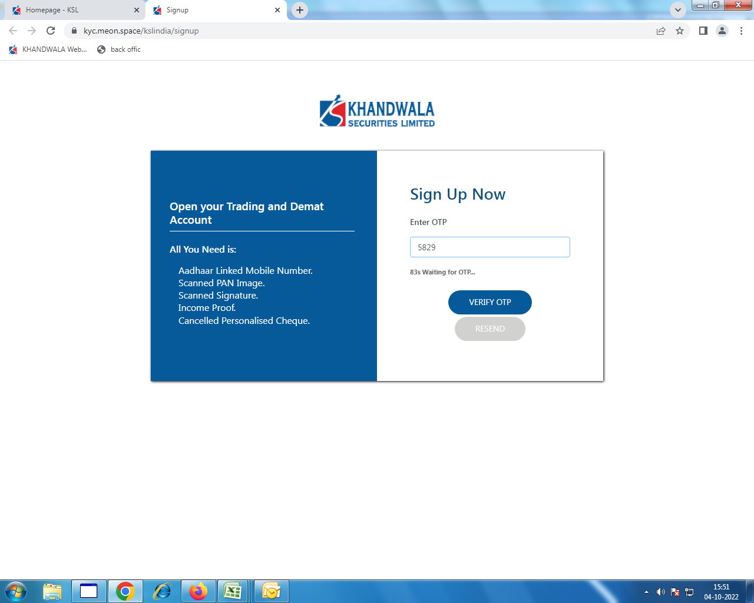

**Email Verification Page 2**

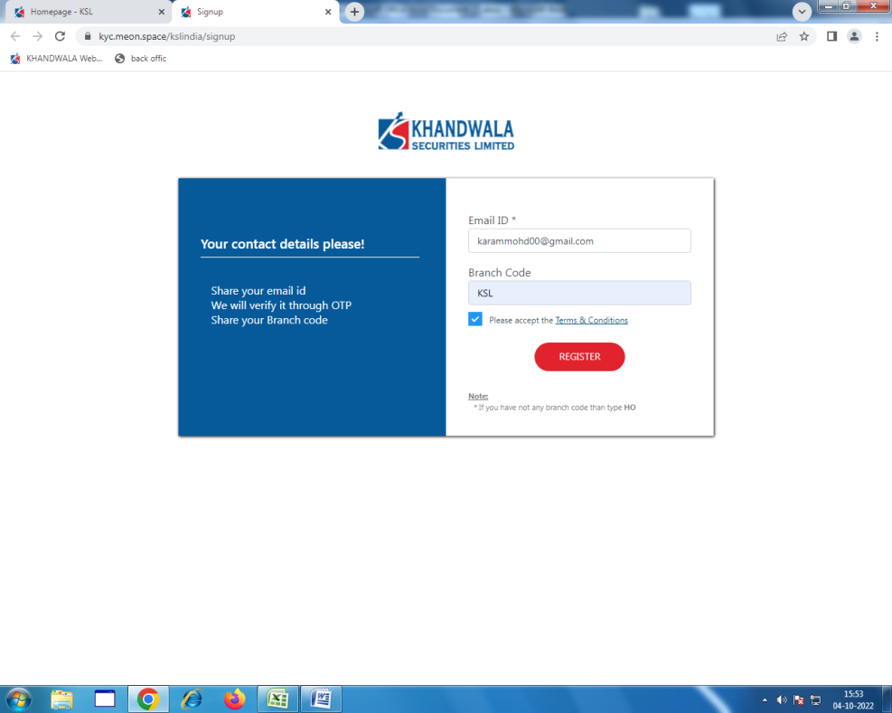

Pan verification page 3

Pan card and Date of Birth

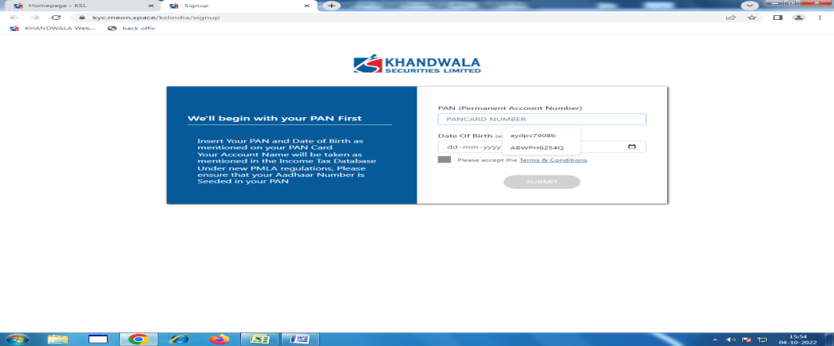

**Select the Brokage Page 4**

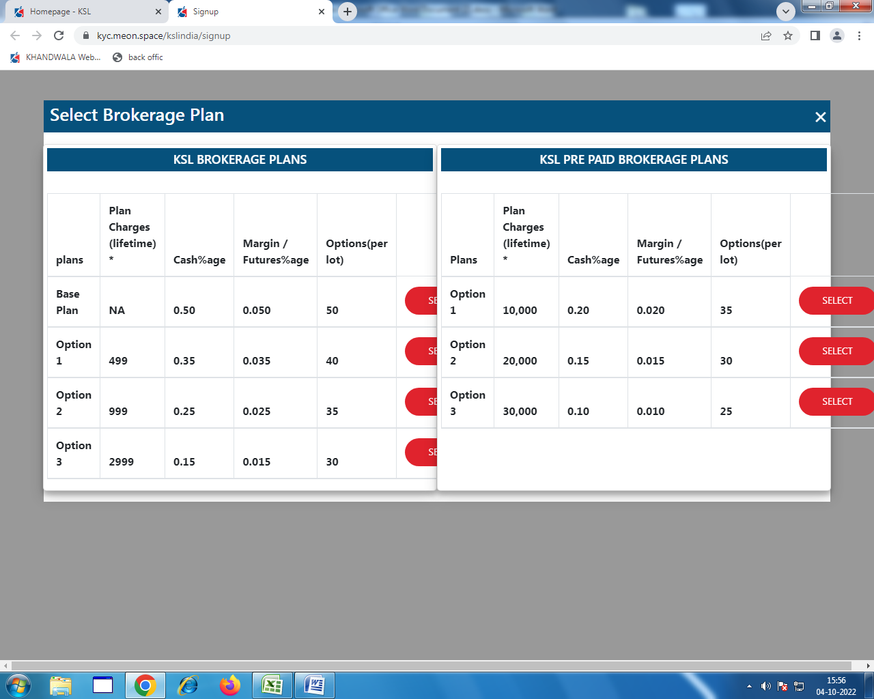

**Choose the Segment Page:- 5**

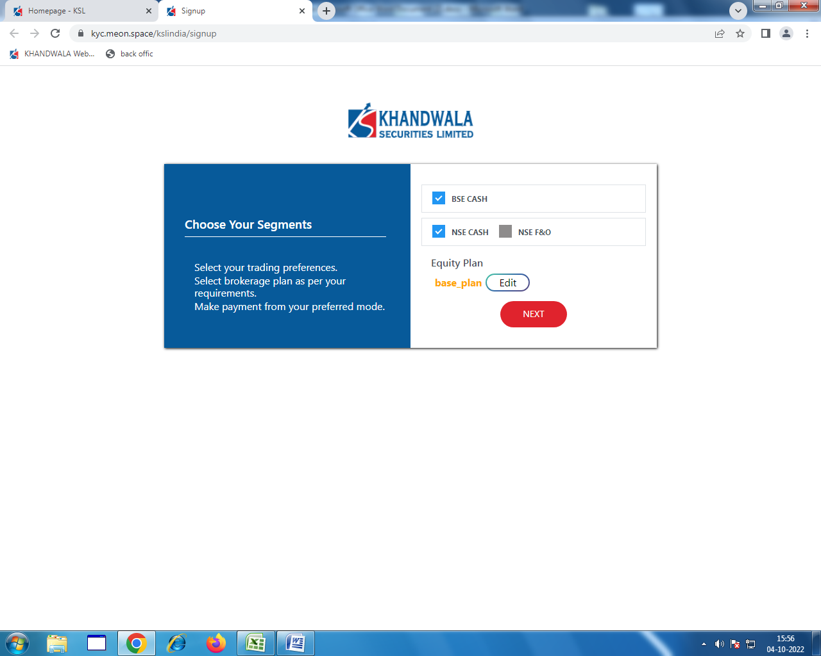

Aadhar Card from Dig locker Page: - 6

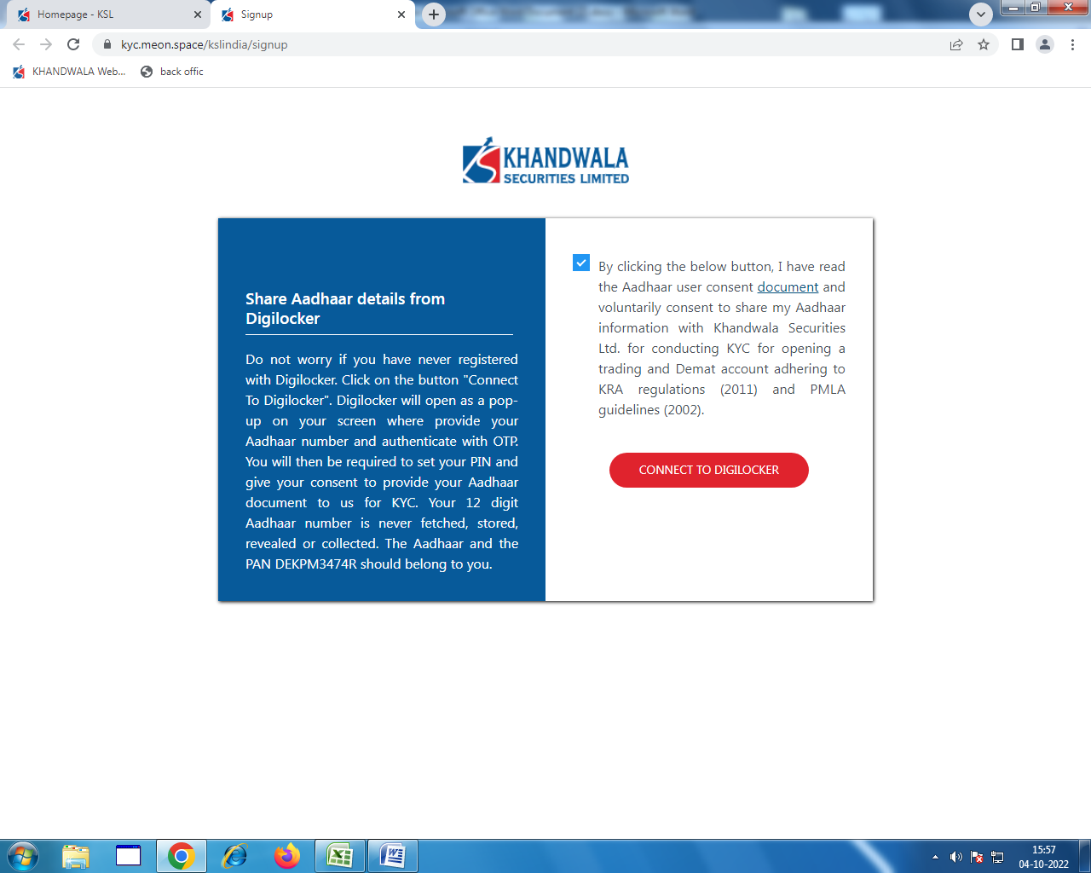

**Udai -Aadhar card dig locker Verification: Page: - 7**

**Update the Aadhar Number**

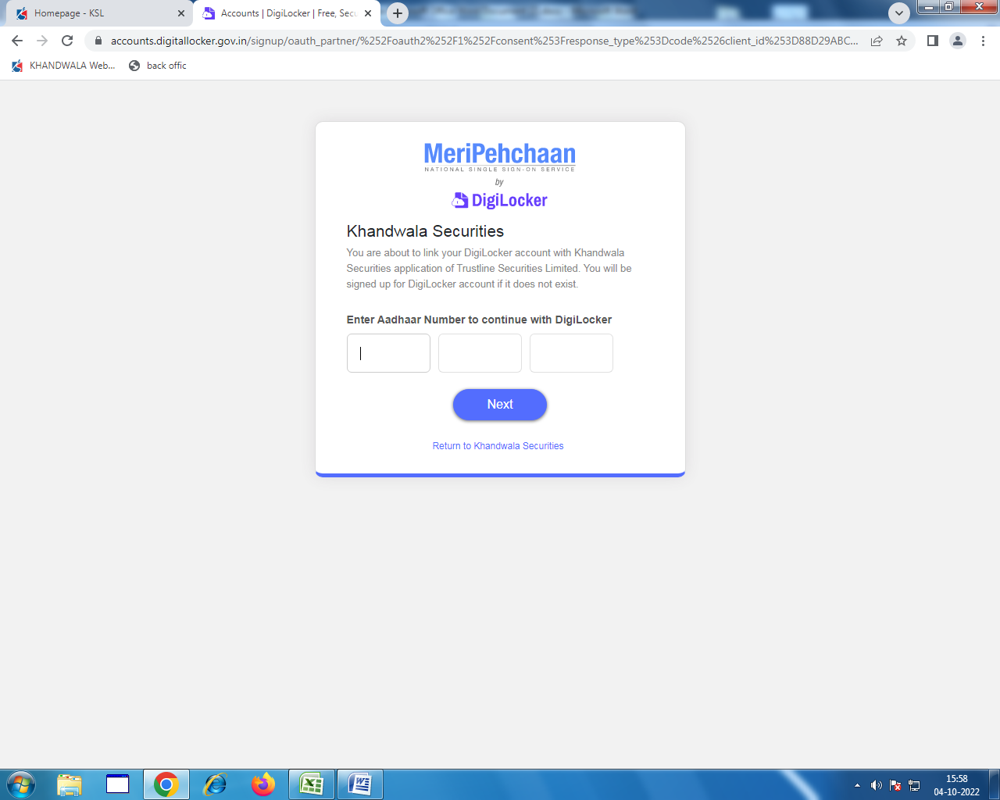

Aadhar Card OTP PAGE: 8

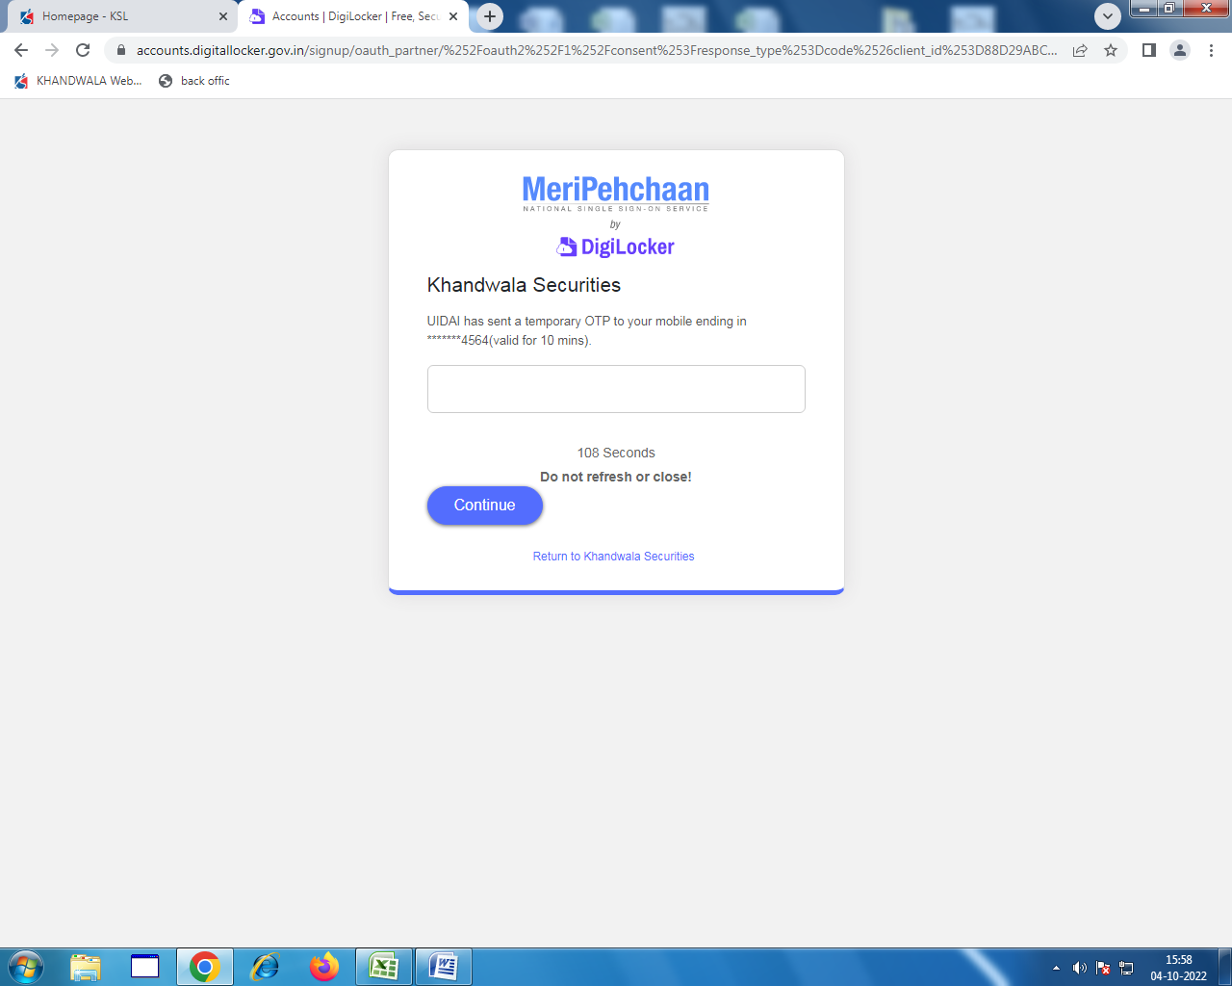

Digi locker confirmation Page 9

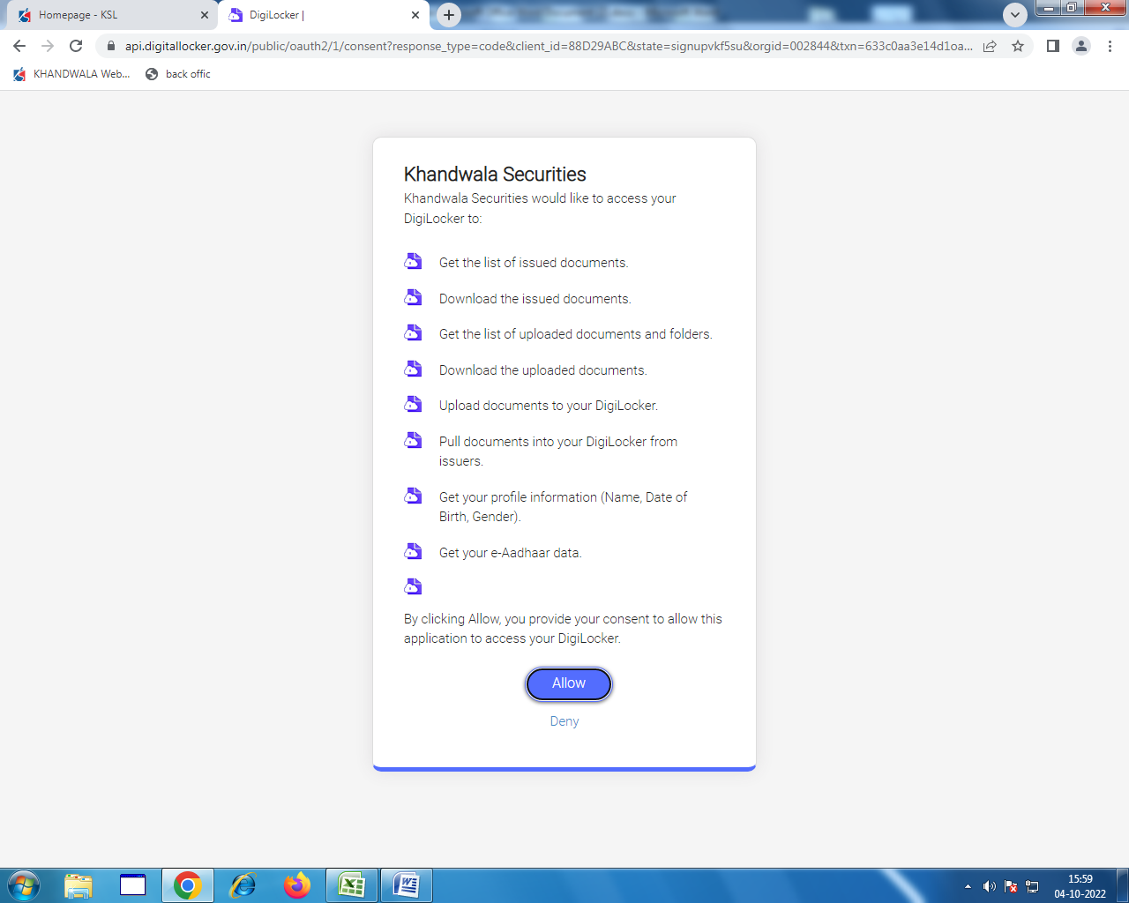

For aadhar Verification Page 10

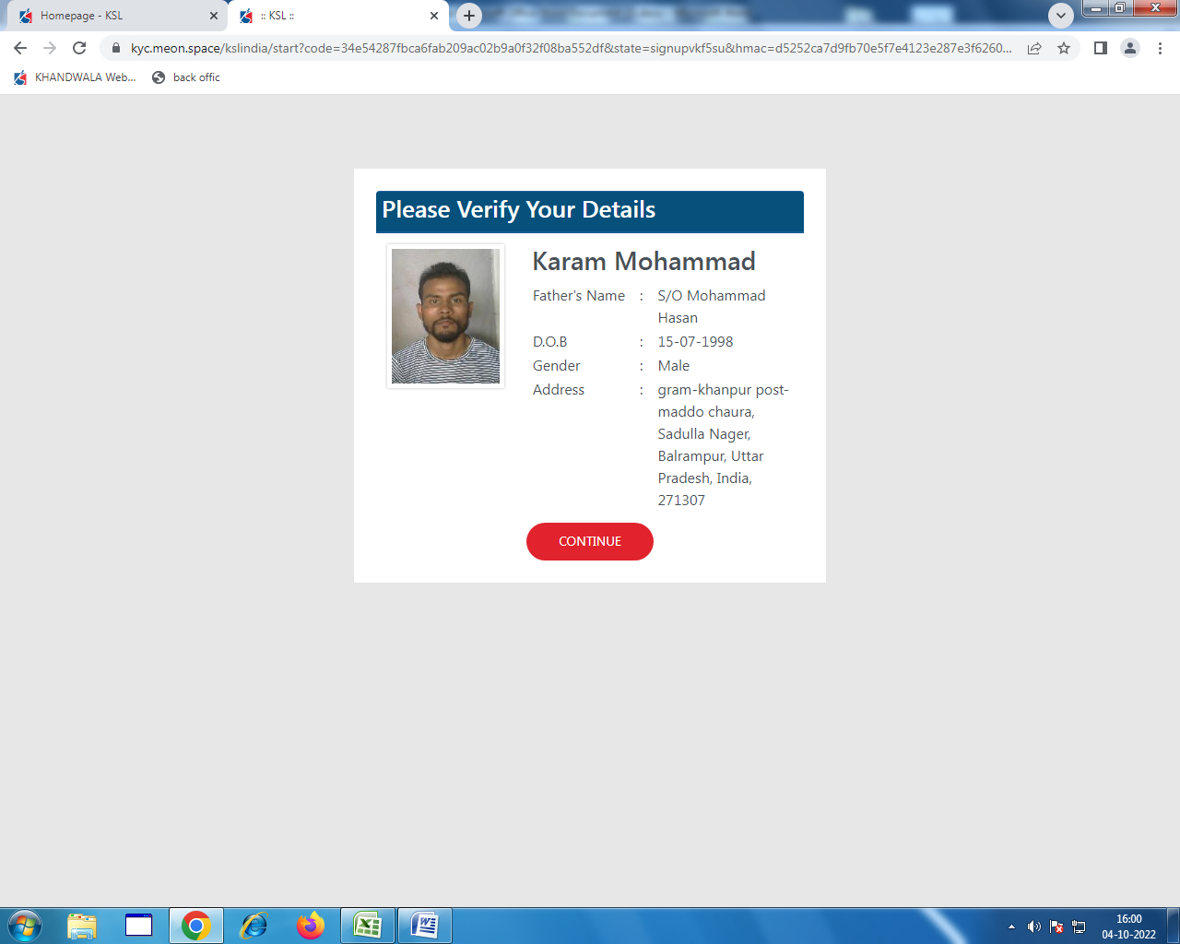

Personal Details: Page 11

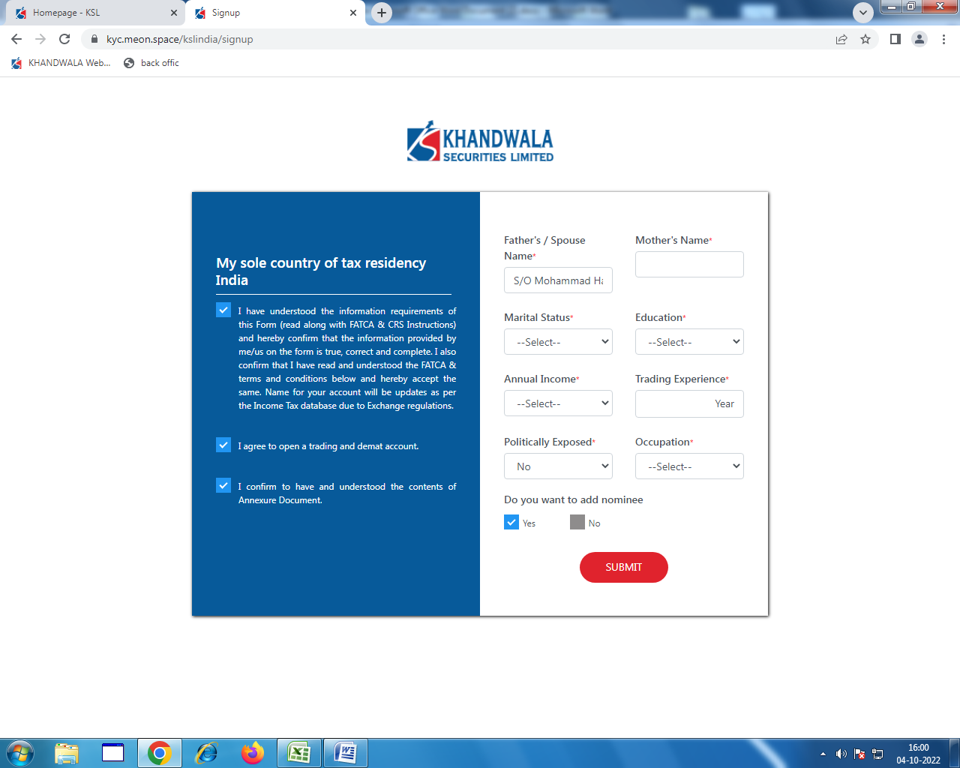

Nominee details with attachment Page 12

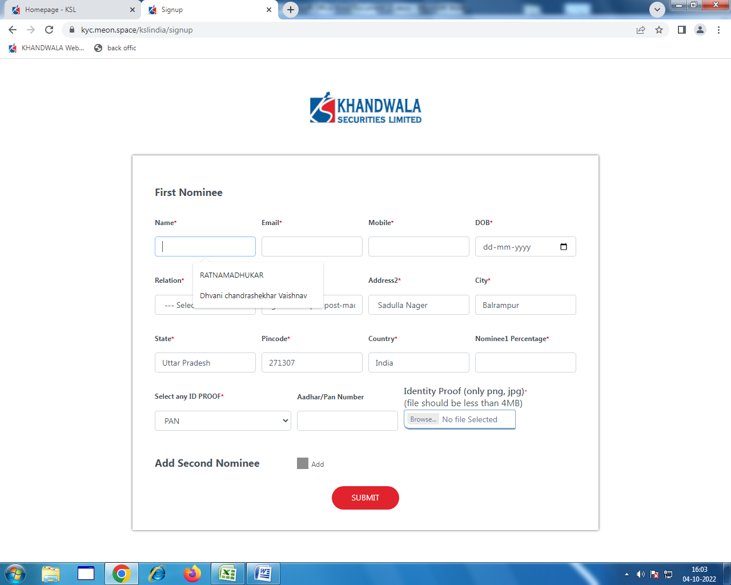

Bank Details Page: 13

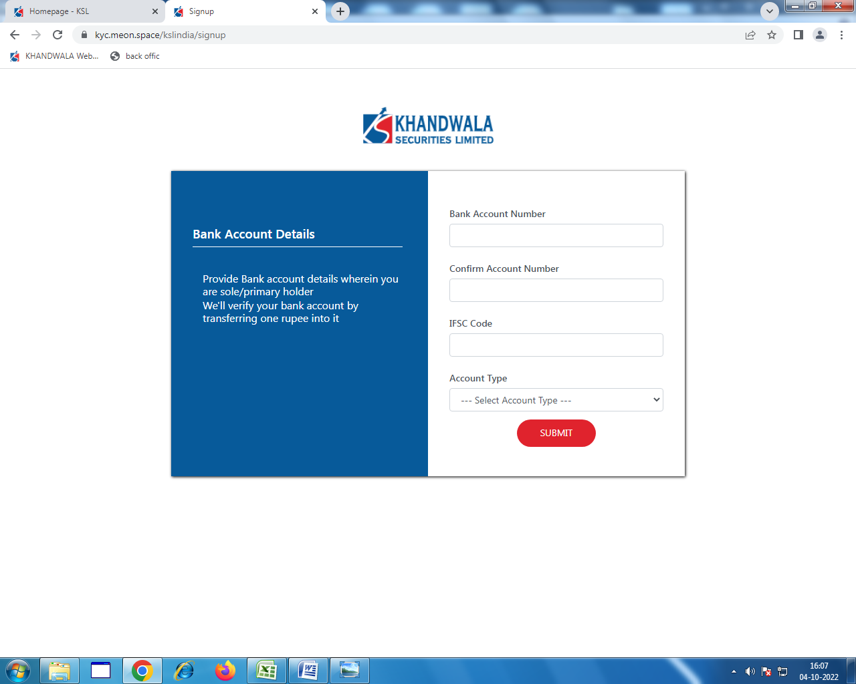

IF Peny drop does not happen then bank proof is require Page: 14

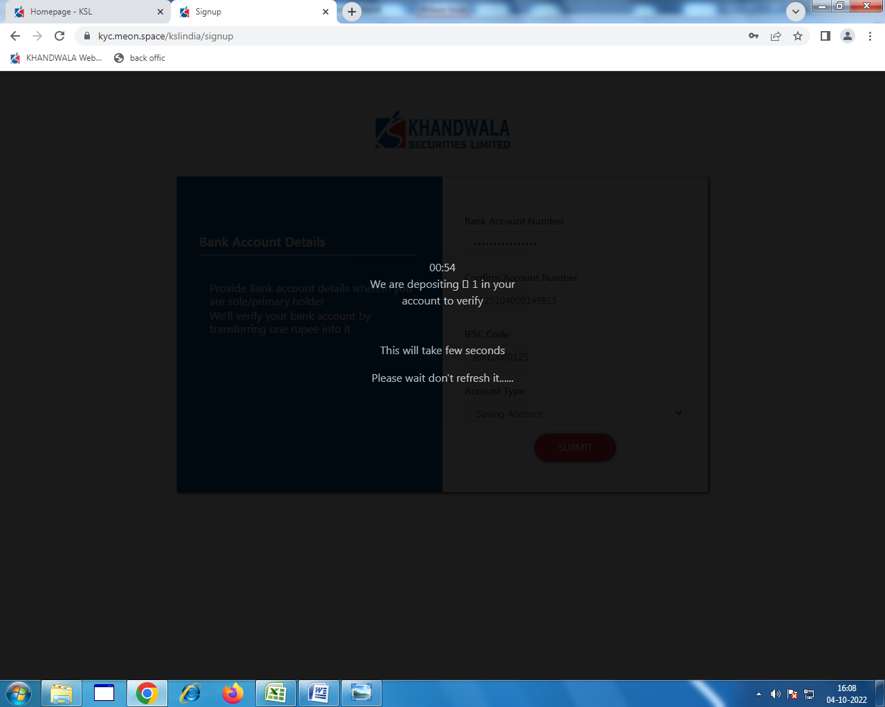

Upload the entire Document in JPG Page 15

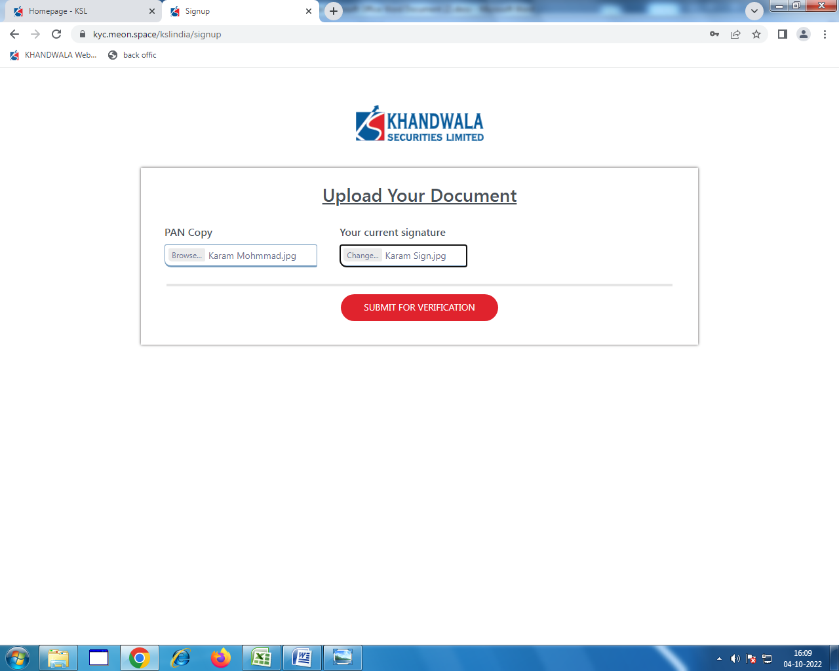

<https://kyc.meon.space/kslindia/signup> for Live photo IPV Page: 16

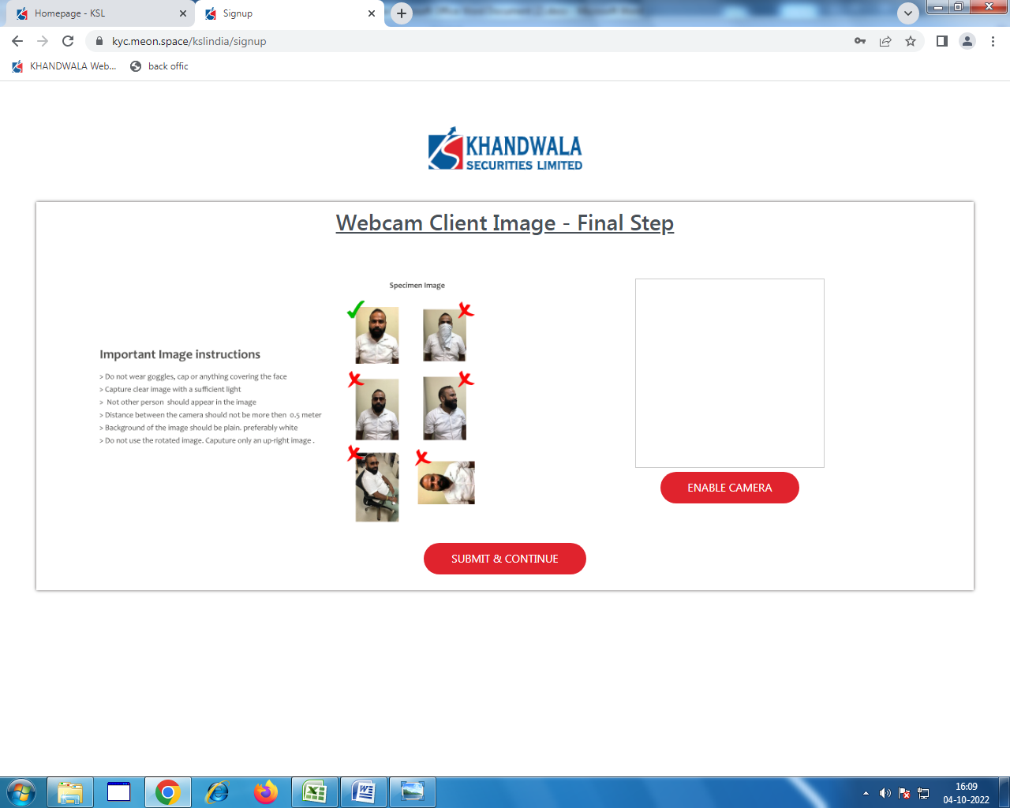

Page 17 KYC Team Verification

After KYC Verification Email goes to Client for E-sign

---------- Forwarded message ---------  
From: <[admin@kslindia.com](mailto:admin@kslindia.com)>  
Date: Tue, Oct 4, 2022 at 4:54 PM  
Subject: KYC ONBOARDING  
To: <[karammohd00@gmail.com](mailto:karammohd00@gmail.com)>

|  |
| --- |
|  |

Please click on this link to esign   
[E-SIGN](https://u9377559.ct.sendgrid.net/ls/click?upn=FFaw4vHAa0oOJkgrbeBFCYq5PbwCamUVpZ3vf0BJJvDYNgCjP6vWhy0LYYA9o10aHePyM0ritCB6k-2FChbCG-2FEBHi8VN4n4HFu0in-2F0yJ-2FqaUIfmfM750zLrlIGdwn26ehFi-2Bk13v01-2B6ohzmYks3uuyzmVJVkjYKjMl8D7P-2BcuWn2Td-2BwTIerPTe6NWxG0TDhxZRKYr4SNG0wOgxfKWG00vYekX39J92CDR7yOplNnnuCAO06LMa2PcjwbIa3dK0d5YD_vX7lv8nw6mMXUaPJPxms-2BfBeIV-2B7LdlhH5xdnegxzN-2BEjTohMMgJJ1H68zK32xij-2FlRPi4cNk0fryAKuEwK-2F8yiSCriZCcfnlXkUQ5wekbZTWHrbPDV9wsDQopuvlTGY4n1EVeANI824rWWpt616tt9XD6I7eRlyYCo-2FKFa4RucTq-2BHcvrkhjSwqVOLDplwEtIy7LmEfLrGOZlXP-2BPG3zQ-3D-3D)  
  
You can permanently skip the PIN approval method by granting Power of Attorney to KSL by mailing us a signed physical copy of the same. Download POA, print, and sign this form:

